An Introduction to BLAST and Local Database Management

Objective: To equip participants with the fundamental skills to perform BLAST searches using a local command-line interface, understand key parameters, and manage sequence databases effectively.
All you want to know about blast: https://www.ncbi.nlm.nih.gov/books/NBK279690/
You can find the scripts in: /mnt/shared/projects/rbge/zedchen/workshop/Blast/command_line_blast.sh

Introduction: What is BLAST?

BLAST (Basic Local Alignment Search Tool) is a fundamental algorithm in bioinformatics used to compare a primary biological sequence (e.g., a nucleotide or protein sequence) against a database of sequences.

The Core Idea: It finds regions of local similarity, not necessarily global alignment. This is faster and biologically more relevant for identifying functional domains or homologous genes.

Have you used blast before, and for what purpose?

Why is it so important?
- Identification: gene (nucl/aa conservation) /species (ITS)
- Function Prediction: Infer the function of a newly sequenced gene
  - (okay but for protein coding genes perhaps some functional domain inferring method like uniport will be better).
- Evolutionary Relationships: Find homologous genes in other species (detecting loci).
- Quality Control: Check the identity of a sequenced clone or PCR product.

Types of BLAST (The "Flavors"):

The type you use depends on your Query and your Database.

Tool | Query | db | Note
blastn | Nucleotide | Nucleotide | Comparing a DNA sequence to a DNA database (e.g., finding a gene in a genome).
blastp | Protein | Protein | Comparing a protein sequence to a protein database (e.g., finding similar proteins with known functions).
blastx | Nucleotide | Protein | Translates your DNA query in all 6 frames and compares it to a protein database. Ideal for identifying potential coding regions in a novel DNA sequence (e.g., from ESTs or RNA-seq).
tblastn | Protein | Nucleotide | Translates the nucleotide database in all 6 frames and compares it to your protein query. Useful for finding genes in unannotated or raw genomic data.
tblastx | Nucleotide | Nucleotide | Translates both the query and database in all 6 frames and compares them at the protein level. Very computationally intensive, used for distant homology.

Key Takeaway: Always match your question to the correct BLAST type.
when can each method be useful?
e.g. hybpiper is using blastx to retrieve reads mapped to the conserved plant protein database (e.g. BUSCO)
---

Set up Bast Environment
create an env and install blast
function setup_env {
conda create --name Blast -y
conda install -c bioconda blast --name Blast -y
conda install -c bioconda seqkit --name Blast -y
}

Try building our own database:
Why build your own database?
- Privacy and security (your data never leaves your server).
- Speed (no network latency).
- Customization (blast against a specific set of sequences, e.g., all proteins from a specific pathway, or your own sequencing data).
- You can also use blast to quickly compare two sets of contigs etc. to identify conserved sequences
function makedb {
DBFA=$1
dbtype=$2
PREFIX=$3
makeblastdb -in $DBFA -dbtype $dbtype -out $PREFIX
}

- Specify the reference fasta file you want to turn into db
- Specify the data type
- Give the db a name
The command will create several new files (e.g., my_custom_protein_db.phr, my_custom_protein_db.pin, my_custom_protein_db.psq for proteins). You don't need to interact with these individually; BLAST will use them automatically
Well the makeblastdb command is not very happy. Let’s see what we can do about it:

Curation of Your Database

A BLAST result is only as good as the database it searches against.

Why Curate?
- Remove redundancy: Too many identical sequences can skew results.
- Improve quality: Remove fragments, sequences with to many unknown residues (XXXX), and misannotated entries.
- Tailor to your needs: Keep only sequences relevant to your specific biological question.
seqkit is a wonderful tool for sequence operations!

Basic statistics
seqkit stats my_database.fasta
Do we want to remove some sequences based on read length etc?

Text corrections
a useful command for text manipulation: sed
How many sequences do we have: egrep -c ‘^>’: is it the same as the file name suggested?
Try to build database once and identify sources of errors:
How do we handle the errors from database construction:

Ambiguous bases
Let’s check what else is the program not happy about:
sed -n ‘Np’: give the Nth line of the file
cat $Lichen_ITS |sed -n ' 5914p'
The invalid residues are ignored but the sequences are kept in the database. You may want to remove the very problematic one such as the sequence at line 6796
cat $Lichen_ITS_clean |sed -n '6786p '
what’s the heading of that record?
cat $Lichen_ITS_clean |sed -n '6785p '
Lichenomphalia_ITS_GenBank_18_Oct_2018.fasta_ALAN_ORANGE_LEGACY

Bad characters in string:
Bad char [0xC3] in string at byte 40
Placopyrenium_cinereoatratum_Pykälä_29279_(E123).fas_ALAN_ORANGE_LEGACY
Verrucaria_hydrophila_ThüsWT1504.fas_ALAN_ORANGE_LEGACY

These bytes represent the character ä ü in UTF-8 encoding
This error message indicates that makeblastdb is encountering non-ASCII characters in your FASTA headers that it cannot properly handle.
Solution:
sed 's/ä/a/g' your_file.fasta > your_file_clean.fasta
Or fixing multiple errors at once:
sed 's/ä/a/g ; s/ü/u/g' your_file.fasta > your_file_clean.fasta
Or using a pipe:
sed 's/ä/a/g' your_file.fasta | sed 's/ü/u/g' > your_file_clean.fasta
Let’s try it again

Remove Duplicates
Cluster sequences at 100% identity:
seqkit rmdup -s my_database.fasta -o my_database_dedup.fasta
how many duplicated records are removed?

Filter by Length?
(not necessary for our example but you may want to use this function in the future)
Using seqkit to keep sequences longer than 50 amino acids
seqkit seq -m 50 my_database_dedup.fasta > my_database_curated.fasta
other filterse?
Manual Inspection
For small databases, manually check the FASTA headers and descriptions to ensure they are relevant and correctly annotated.

Run the makeblastdb command:
function makedb {
DBFA=$1
dbtype=$2
PREFIX=$3
makeblastdb -in $DBFA -dbtype $dbtype -out $PREFIX
}

- Specify the reference fasta file you want to turn into db
- Specify the data type
- Give the db a name

Basic Blastn
Blasting nucleotides against nucl database
A basic blastn command:
blastn -db $PREFIX -query $Q -outfmt $FMT > $OUTDIR/blast_${OUTNAME}.txt
Hands-on Exercise: let’s try to blastn and examine different output format
BLAST® Command Line Applications User Manual
https://www.ncbi.nlm.nih.gov/books/NBK279684/

choose a task
The blastn and blastp applications have a –task option. This option sets the parameters (e.g., word-size or gap values) to typical values for a specific type of search.
For example, the “megablast” task is optimized for intraspecies comparison as it uses a large word-size, whereas “blastn” is better suited for interspecies comparisons with a shorter word-size. These tasks resemble the “Program Selection” section of the BLAST web pages and do not preclude the user from setting other options to override those specified by the task.
The following tasks are currently available:
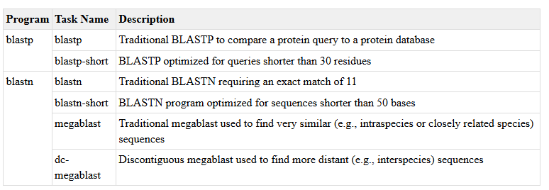
the default task is blastn

Modifying BLAST Parameters
The default parameters work well, but fine-tuning is often necessary. Let's explore the most common ones.
There are a lot more to this as you may want to go through the user manual https://www.ncbi.nlm.nih.gov/books/NBK279690/ later when you have a specific need. but here are some examples:

Key Parameters:

E-value (-evalue): The expectation value. Lower E-values mean more significant hits. Use -evalue 1e-10 for a very stringent threshold.
Word Size (-word_size): The initial "seed" length. Smaller word sizes increase sensitivity (and time) for more distant relationships.
For blastp, default is 3. For more sensitive search, use 2.
For blastn, default is 11. For finding short matches, use 7.
Output Format (-outfmt): We saw -outfmt 6 for tabular. You can customize this extensively. -outfmt "6 qseqid sseqid pident evalue" would output only those four columns.
Number of Alignments (-num_alignments): Limits the number of database sequences for which alignments are shown
Max Target Seqs (-max_target_seqs): Limits the number of aligned sequences to report. Important: Always set this explicitly to avoid non-deterministic results! (-max_target_seqs 100). : most of the times we only are interested in the very good alignments at the top

Example Command with Modified Parameters:

bash
blastp -query my_query.fasta -db my_custom_db -out stringent_results.txt -evalue 1e-20 -word_size 2 -max_target_seqs 50 -outfmt 6

what format outputs are we using
different format gives different alignment view option. The options are coded as numbers:
0 = pairwise (this is also the default),
1 = query-anchored showing identities,
2 = query-anchored no identities,
3 = flat query-anchored, show identities,
4 = flat query-anchored, no identities,
5 = XML Blast output,
6 = tabular,
7 = tabular with comment lines,
8 = Text ASN.1,
9 = Binary ASN.1
10 = Comma-separated values
11 = BLAST archive format (ASN.1)
12 = Seqalign (JSON),
13 = Multiple-file BLAST JSON,
14 = Multiple-file BLAST XML2,
15 = Single-file BLAST JSON,
16 = Single-file BLAST XML2,
17 = Sequence Alignment/Map (SAM),
18 = Organism Report

We will look at a few of the more useful/classic formats

-outformt 0
Human-readable, aligned output with query-subject matches
This is basically what you see if you use the web Blast on NCBI
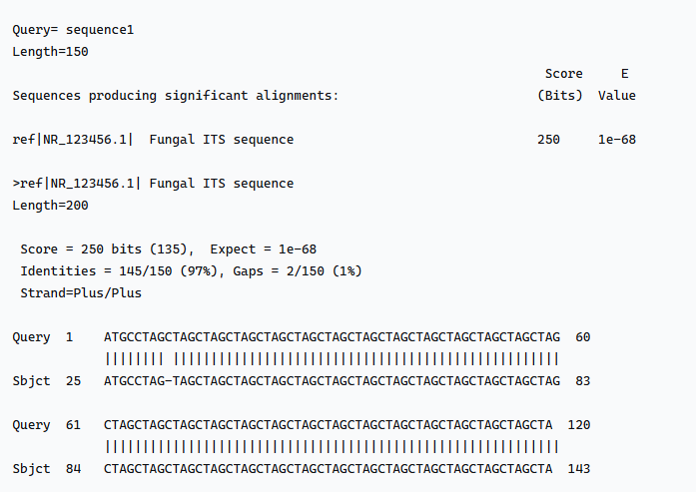
When would you want to see an output like this?
What’s the problem with this output?

-outformt 1
1 = query-anchored showing identities
Basically, it shows the alignment of all hits: ‘.’ Means identical as the query sequence
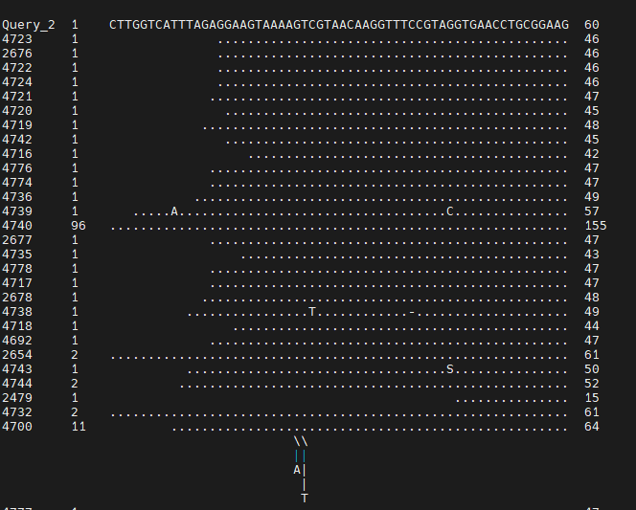
All the hits are aligned. This is similar to the graphic summary option in web BLAST
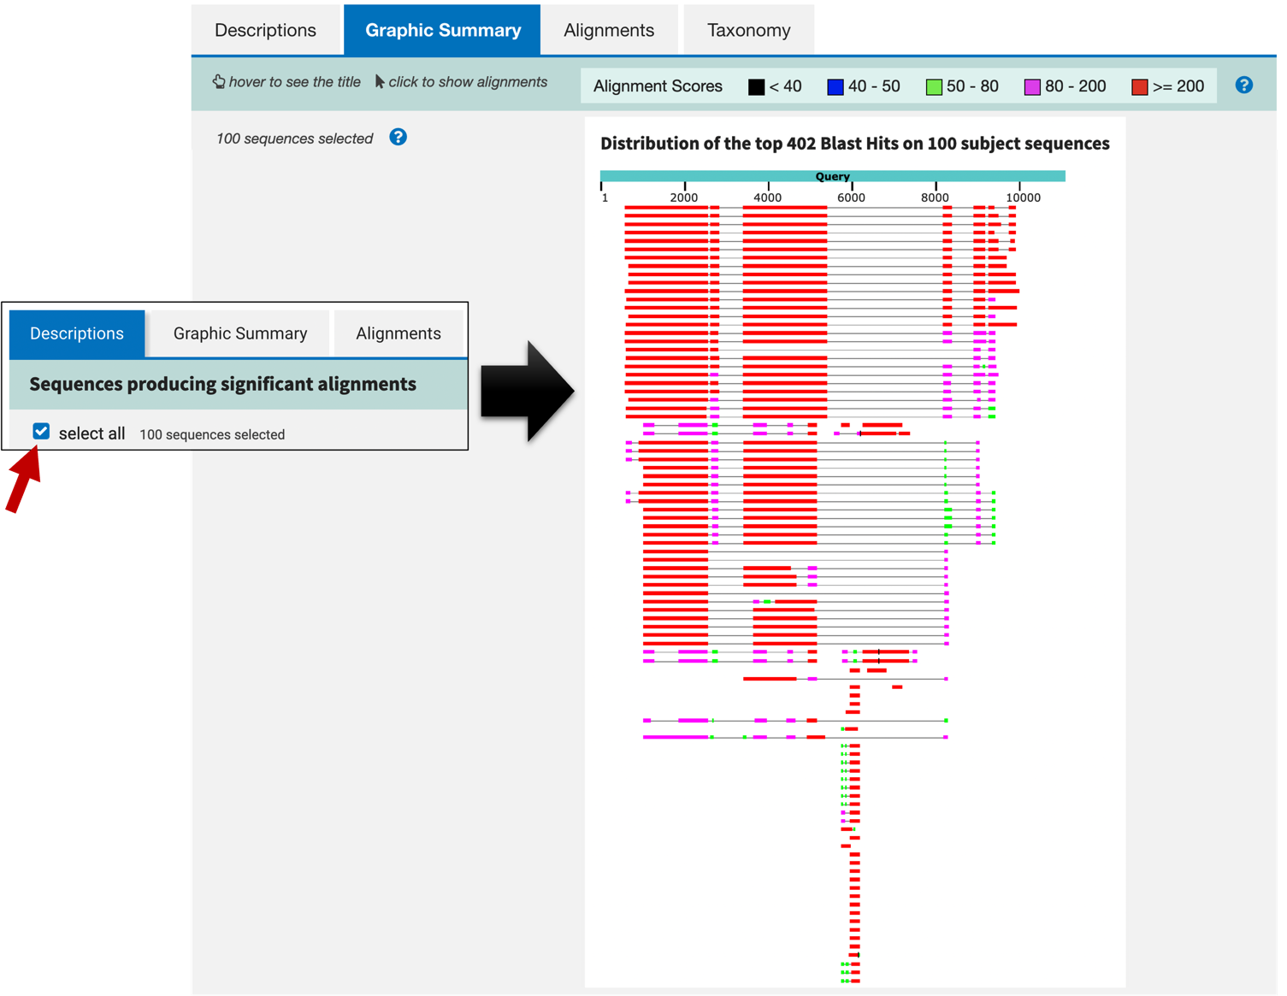

-outformt 2
Same as format 1, but instead of ‘.’ it shows the actual bases

-outformt 3
Same as format 1 but absorbing all the indels into the sequences
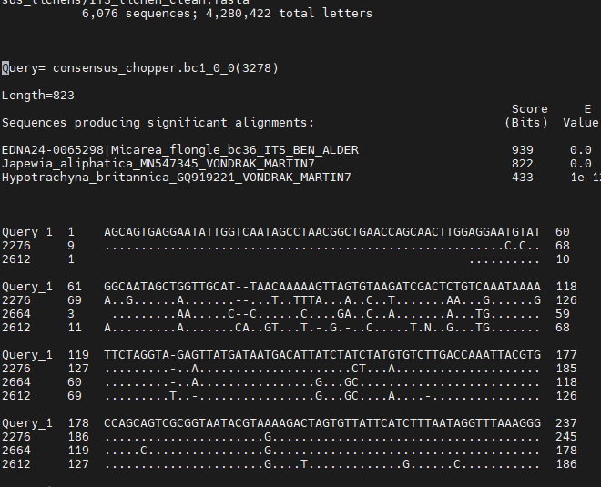

-outformt 4
Same as outformat 3 but showing actual bases
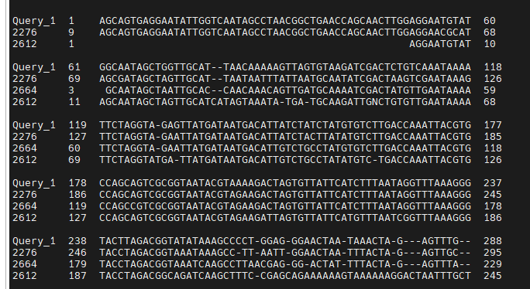

-outformt 5
XML Blast output, similar to webpage. You can extract information from each field (those things bound by two <>) using tools such as xtract.
What information you probably would like to get from this file?

-outformt 6
This is potentially the most useful format for quick summar!
A nice tab delimited file with 12 fields:
qseqid sseqid pident length mismatch gapopen qstart qend sstart send evalue bitscore
1. qseqid query or source (gene) sequence id
2. sseqid subject or target (reference genome) sequence id
3. pident percentage of identical positions
4. length alignment length (sequence overlap)
5. mismatch number of mismatches
6. gapopen number of gap openings
7. qstart start of alignment in query
8. qend end of alignment in query
9. sstart start of alignment in subject
10. send end of alignment in subject
11. evalue expect value
12. bitscore bit score

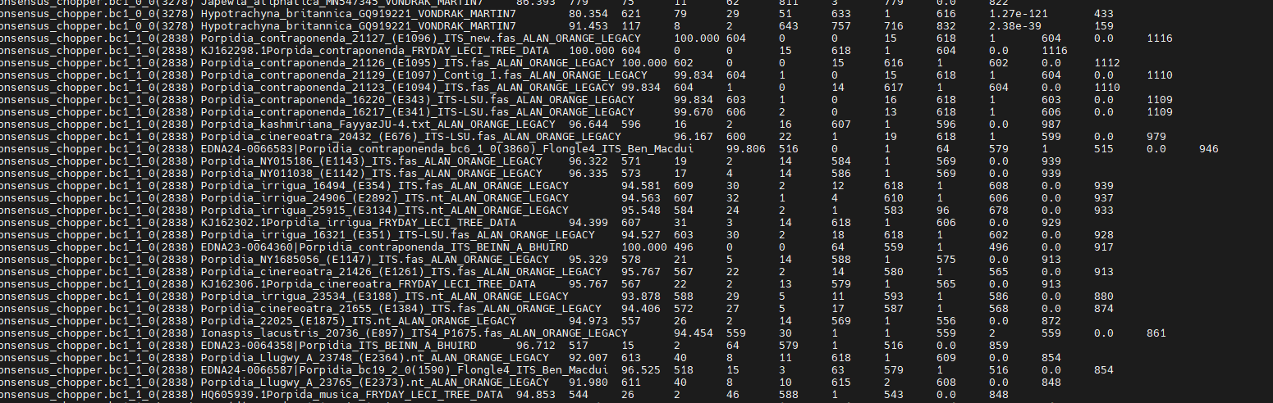
Options 6, 7, and 10 can be additionally configured to produce a custom format specified by space delimited format specifiers
evalue
a statistical measure of the probability of finding a match by chance in a BLAST search; to the e-value in statistics, an alternative to p-values.
Compare e value and p value:
An e-value (evidence-value) is a statistical measure quantifying evidence against a null hypothesis, while a p-value is a probability of observing data as extreme as or more extreme than the observed data, assuming the null is true
So basically: e value is ‘chance that null is not true’ vs p value is ‘chance of have the observed result when null is true’
Lower e value = better/more specific/aligned match (less likely to occur by chance alone)
Large E-value: many hits, partly of low quality
Bit score:
The higher the bit-score, the better the sequence similarity
The bit-score is the requires size of a sequence database in which the current match could be found just by chance. The bit-score is a log₂ scaled and normalized raw-score. Each increase by one doubles the required database size (2^{bit-score}).
Bit-score does not depend on database size. The bit-score gives the same value for hits in databases of different sizes and hence can be used for searching in an constantly increasing database.

Appendix: format specifiers
And we have a long long list of supported format specifiers (check what do you need. Otherwise most of the time the 12 default specifiers are sufficient):
qseqid means Query Seq-id
qgi means Query GI
qacc means Query accesion
sseqid means Subject Seq-id
sallseqid means All subject Seq-id(s), separated by a ';'
sgi means Subject GI
sallgi means All subject GIs
sacc means Subject accession
sallacc means All subject accessions
qstart means Start of alignment in query
qend means End of alignment in query
sstart means Start of alignment in subject
send means End of alignment in subject
qseq means Aligned part of query sequence
sseq means Aligned part of subject sequence
evalue means Expect value
bitscore means Bit score
score means Raw score
length means Alignment length
pident means Percentage of identical matches
nident means Number of identical matches
mismatch means Number of mismatches
positive means Number of positive-scoring matches
gapopen means Number of gap openings
gaps means Total number of gap
ppos means Percentage of positive-scoring matches
frames means Query and subject frames separated by a '/'
qframe means Query frame
sframe means Subject frame
btop means Blast traceback operations (BTOP)
staxids means unique Subject Taxonomy ID(s), separated by a ';'(in numerical order)
sscinames means unique Subject Scientific Name(s), separated by a ';'
scomnames means unique Subject Common Name(s), separated by a ';'
sblastnames means unique Subject Blast Name(s), separated by a ';' (in alphabetical order)
sskingdoms means unique Subject Super Kingdom(s), separated by a ';' (in alphabetical order)
stitle means Subject Title
salltitles means All Subject Title(s), separated by a '<>'
sstrand means Subject Strand
qcovs means Query Coverage Per Subject (for all HSPs)
qcovhsp means Query Coverage Per HSP
qcovus is a measure of Query Coverage that counts a position in a subject sequence for this measure only once. The second time the position is aligned to the query is not counted towards this measure.
When not provided, the default value is:
'qseqid sseqid pident length mismatch gapopen qstart qend sstart send evalue bitscore', which is equivalent to the keyword 'std'

Case1: Extract best hits using outfmt 6: Identification
Well we basically done case 1 by now.
For each query sequence, BLASTN hits are ordered by a combination of bit score and E-value, with the highest bit scores and lowest E-values (representing the most significant matches) appearing at the top of the results. Both metrics are crucial for assessing the statistical significance of a hit, with bit score indicating the quality of the alignment and E-value showing the likelihood of such an alignment occurring by chance in a database of a given size.
Let’s try to extract the top hit for each query sequence then:
$Q is the fasta file with query sequences, in the case of the tutorial, the consensus

for l in $(egrep '^>' $Q);
do
l=${l/>/}
cat $OUTDIR/blast_${OUTNAME}.txt |grep $l|head -n 1 >> $OUTDIR/tophits_${OUTNAME}.txt
done
You what if you choose to get the one with the highest ID or the longest alignment? What might be a problem with such an approach?
$Q is the fasta file with query sequences, in the case of the tutorial, the consensus

for l in $(egrep '^>' $Q);
do
l=${l/>/}
cat $OUTDIR/blast_${OUTNAME}.txt |grep $l|sort -t$'\t' -k3,3 -nr -k4,4 -nr|head -n 1 >> $OUTDIR/tophits_${OUTNAME}.txt
done
Can also out put the top three hits: head -n 3
This will give us a primary result for what species are represented by the consensus file
Well, that’s about the end of this task. But we can do a lot more using the blast output

Case2: Extract best hits using outfmt 6: LOCI DETECTION
A more recent request I got this week concerns the moss genus Andreaea:
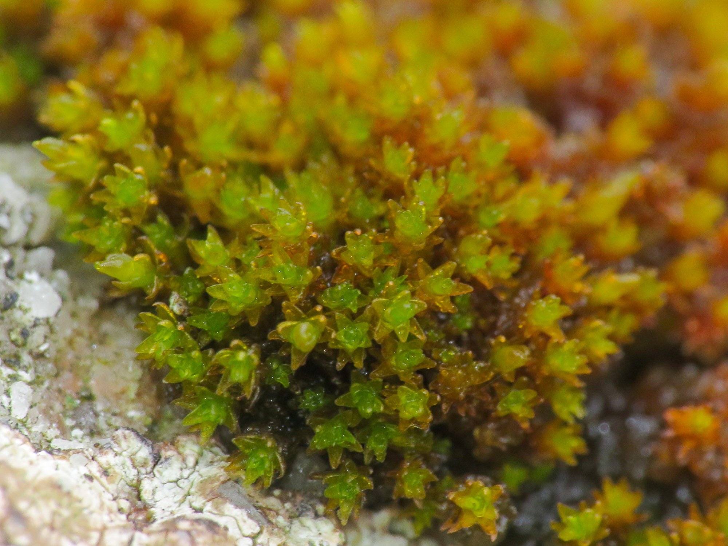

Question
We got a set of loci sequences and genome assemblies of Andreaea species from online databases.
Now we want to identify and extract the same loci from the assemblies and add them to the phylogeny we are building for Andreaea
How will we design the database? What will you use as the query vs database?
(there are 389 loci to look at. So this is a task best done with array or a for loop. For our purpose, we will look at just one of these loci
THE LOCI: $HOME/projects/rbge/zedchen/workshop/Blast/L288.Andreaea.Target.names.fa
THE GENOME: $HOME/projects/rbge/zedchen/workshop/Blast/A_rothii_chromosome.fasta
How do the query look like? How might we choose the query sequence?

Download from online database: ENA
The genome is from DToL Project and put on ENA:
https://www.ebi.ac.uk/ena/browser/view/GCA_965644345.1
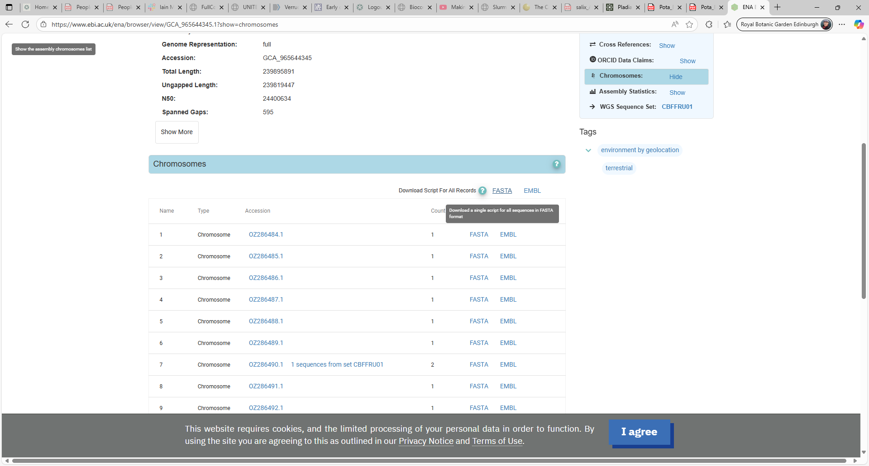
get the wget commands:

You then end up with something like this, which you can add to your script to download all chromosomes and keep good record:
wget https://www.ebi.ac.uk/ena/browser/api/fasta/OZ286484.1 -O - >> GCA_965644345-chromosomes.fasta
wget https://www.ebi.ac.uk/ena/browser/api/fasta/OZ286485.1 -O - >> GCA_965644345-chromosomes.fasta
wget https://www.ebi.ac.uk/ena/browser/api/fasta/OZ286486.1 -O - >> GCA_965644345-chromosomes.fasta
……

for instance I would organise the download task for each species into a part of the script:

function download_ENA {

OUTDIR=$1
SPECIES=$2
START=$3
END=$4
CHROM_ACC=$5
OUTFILE=${OUTDIR}/${SPECIES}_chromosome.fasta
# Only download if file doesn't exist or is empty
if [ ! -f $OUTFILE ] || [ ! -s $OUTFILE ]; then
for i in $(seq $START $END); do
wget https://www.ebi.ac.uk/ena/browser/api/fasta/${CHROM_ACC}${i}.1 -O - >> $OUTFILE
done
else
echo "dataset already downloaded $OUTFILE, skipping..."
fi
}
#now actually use the function
download_ENA ${RESULT1} A_rothii 84 96 OZ2864 GCA_965644345
download_ENA ${RESULT1} A_nivalis 11 21 OZ2813 GCA_965637445
download_ENA ${RESULT1} A_mutabilis 12 23 OZ2862 GCA_965644055
download_ENA ${RESULT1} A_hookeri 24 34 OZ2464 GCA_965231225
#process_sp_ENA ${RESULT1} ${RESULT2} A_frigida 592 604 OZ286 GCA_965644415 #all found
you will need to design it differently if you are using different database, such as SRA or NCBI etc.
but the take home is
- it is a good idea to make something reusable (a function)
- it is good to keep record of how and where you got your data

build your own database and Blast
now we can use the genome assembly as a database and the loci sequences as queries to detect the loci in our new Andreaea species:
what did you notice about the blast output of L288? How many hits does each sequence get?
Can we sort the output in a sensible way?

Extract the loci for A. rothii
Well, not quite, as it requires some python scripting, but at least you will know how to do it theoretically:
On which chromosome can you find the loci?
The coordinate?
What data format is the chromosome? How can we access it and manipulate the sequence?
BioPython…
Presume we got the loci from A. rothii, now we can add it back to the set of loci we have and rerun and phylogeny building program (IQtree etc.)
What’s missing? Outgroups?

And beyond
Remember we often have hundreds of loci to process
That’s when scripting become useful: for loop or parallelizing
It really speeds up the task when you’re doing the same operation for all the inputs

Conclusion & Next Steps

Congratulations! You now know how to:
- Choose the right BLAST program for your task.
- Create a custom BLAST database from a FASTA file.
- Run a BLAST search locally and interpret the output.
- Curate a high-quality database.

Repeat is key! Try building a database for your favorite gene family, or download all proteins from a model organism and use it as a resource for your future analyses.

Questions
How to get a new database/update the current database?
Modify key parameters to refine your search?
What web resources can we use for getting reference sequences/reads?
What might contribute to false positives? How can we deal with those?
How to reduce false positive?

